
كلية العلوم الحاسوبية والمعلوماتية
Faculty of CSI

Green print

Students:
Furat Salah | 202110558
Doaa Almoathen | 202110335

Supervisor:
Dr. Alaa Abu Thawabeh

Amman - Jordan
2024/2025

Table of contents

Content | Page
1.1 Problem Statement and project Scope | 3
1.2 Project Plan and Schedule | 3
2. System Analysi | 4
2.1 Functional Requirements | 4
2.2 Use Case Diagram | 5
3. System Design | 6
3.1 ER-Diagram | 6
3.2 User Interface | 7,8.9,10,11

List of figures

Figure | Title | page
1.2 | Gantt Chart of Green Print system | 3
2.2 | Use Case diagram of Green Print system | 5
3.1 | ER diagram of Green Print system | 6
3.2 | UI of Green Print system | 7,8,9
3.4 | Edit UI of Green Print system | 10
3.5 | Delete UI of Green Print system | 11

  - Problem Statement and project Scope

The system has been facing problems due to its paper-based appointment
system. With the increase in the number of patients visiting, it has
become diﬃcult to manage the appointment system manually. Recording
of appointments and creating registers by pen and paper has become a
The world is increasingly facing the consequences of climate change, yet many individuals are unaware of the impact their daily habits have on the environment.
There is currently a lack of accessible tools that help users calculate their carbon footprint based on their lifestyle choices and.

The aim of this project is to develop a web-based system called GreenPrint, which calculates a user’s estimated carbon footprint based on input about transportation, diet, and energy usage.

This contributes to the goals of sustainable development by promoting environmental awareness and personal responsibility.

  - Project Plan and Schedule

This Gantt chart outlines the main project tasks scheduled from April to May 2025.
It begins with "Project Proposal & Requirements Gathering" and initial database setup.
System design and analysis follow, running in parallel with continued development tasks.
The project concludes with integration, testing, and final report submission in late May.
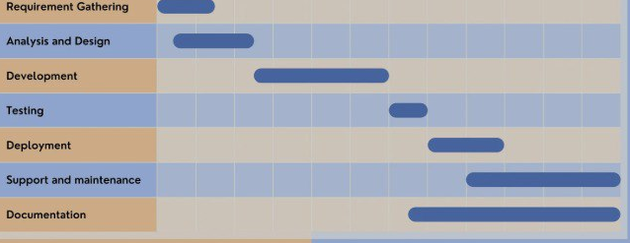
Figure 1.2: Gantt Chart of Green Print system

- System Analysis

FR1. User Registration and Login
FR1.1 Users can register with a username, email, and password.
FR1.2 Users can log in securely using email and password.
FR1.3 The system validates email format and ensures strong passwords.
FR1.4 Admin can manage user accounts.

FR2. Carbon Footprint Input and Calculation
FR2.1 Users input their data regarding transport, energy usage, and diet.
FR2.2 The system calculates carbon emissions based on standard emission factors.

2.2 Use Case Diagram

The Green Print system helps users understand their carbon footprint and find ways to reduce it. Users can create an account, log in, and enter details about their lifestyle. Based on this, the system calculates their carbon footprint and gives suggestions to improve it. Users can view both their results and the suggestions. An admin is also involved to manage user accounts.

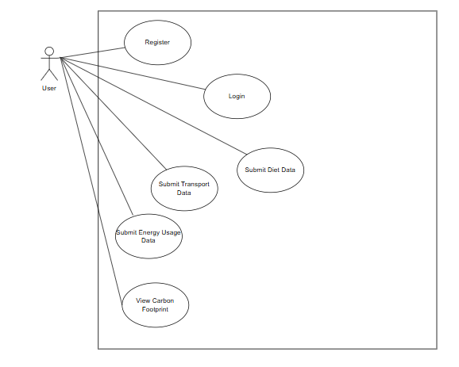

Figure 2.2 Use case Diagram for Green Print

3. System Design

3.1 ER-Diagram

This ER diagram represents a carbon emission tracking system. Users submit carbon data, which includes details like diet, shopping, transport, and energy usage.

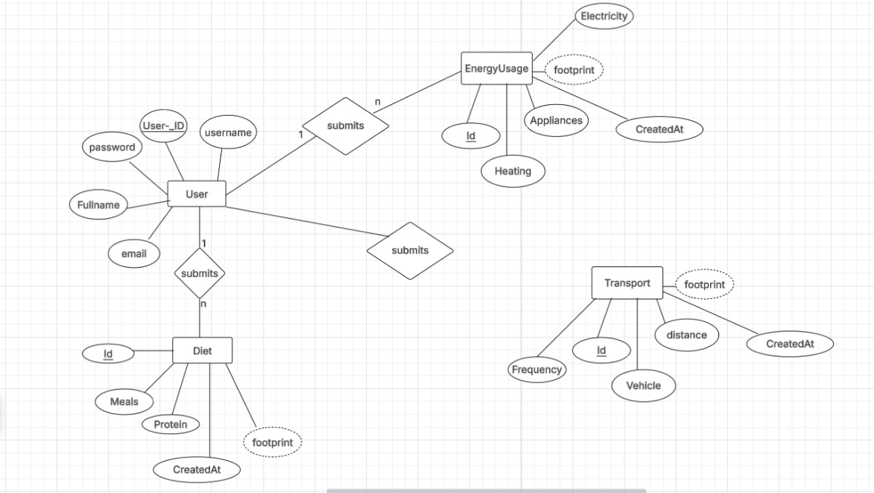
n
1

Figure 3.1: ER diagram of Green Print system

3.2 User Interface (prototype)

The Green Print homepage features a clean, modern layout with a top navigation bar and a prominent green Sign Up button. The hero section displays a nature-themed background, a bold headline "Journey to Sustainability", and a clear Get Started call-to-action. The design highlights the site’s focus on promoting eco-friendly initiatives and user engagement.

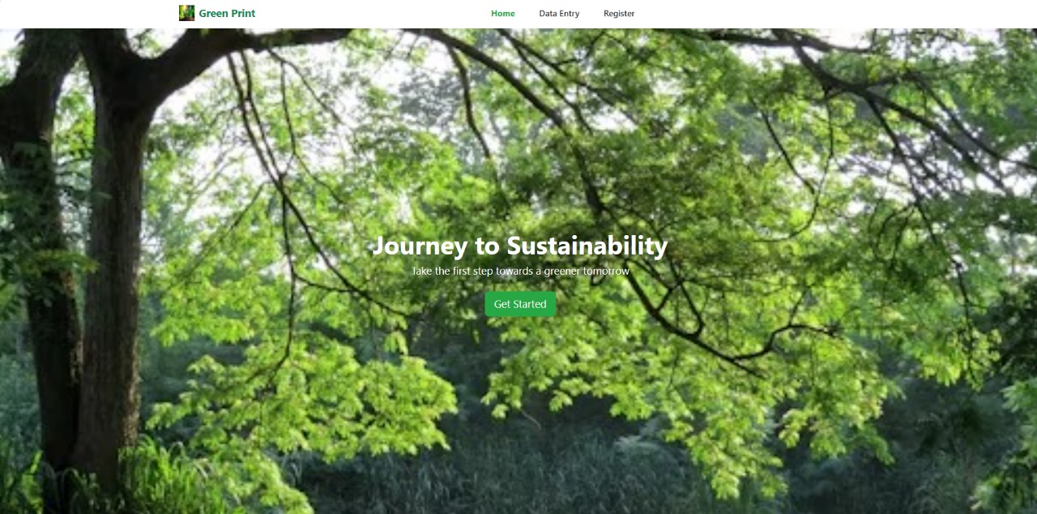

Figure 3.2: Home Page of Green Print system

This is the Register page of the Green Print website. It features a simple and clean layout with input fields for Username, Email, and Password. A green Sign Up button allows users to create an account, while a login link is provided for existing users. The design is minimal and user-friendly, aligning with the site's overall eco-focused theme.

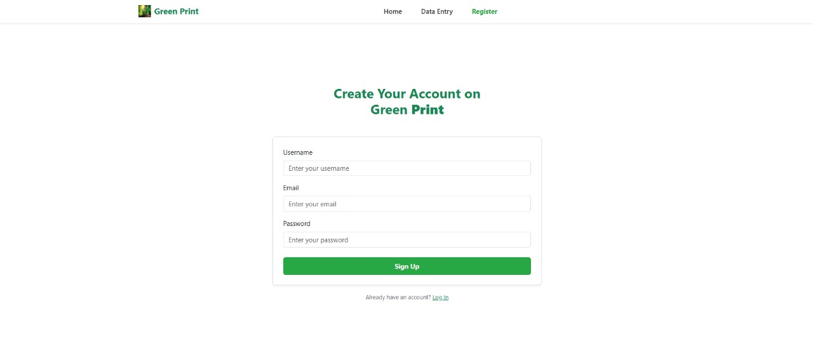
Figure 3.2: Create Account of Green Print system

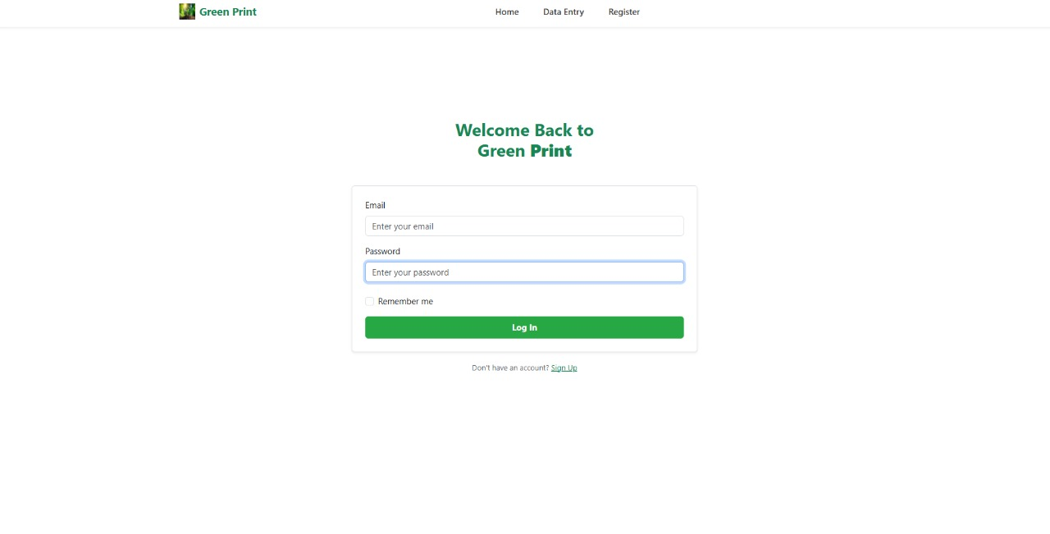
Figure 3.2: Log in of Green Print system

This figure on the Green Print site features a Data Entry form divided into three sections: Energy Usage Data, Transport Data, and Shopping Habits Data. Each section includes clearly labeled input fields to collect user information, such as electricity usage, transport methods, and shopping frequency.

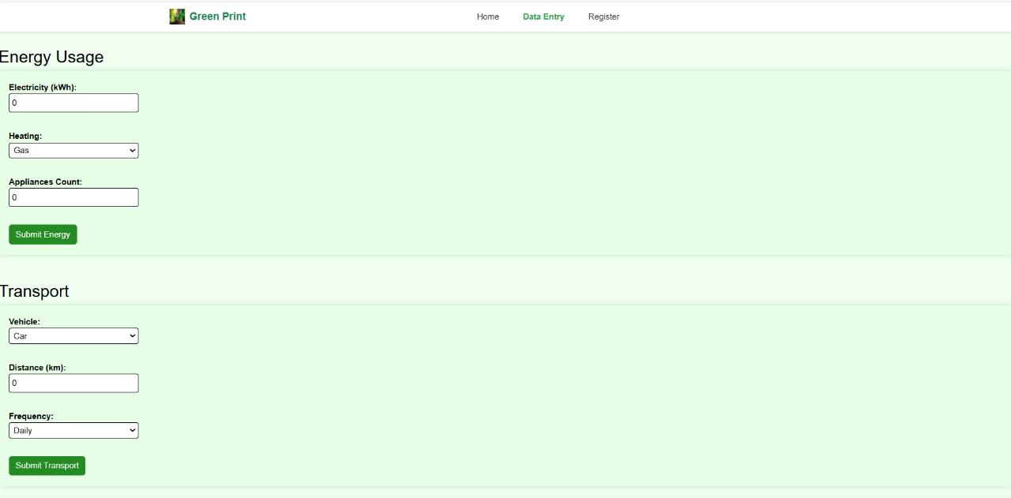
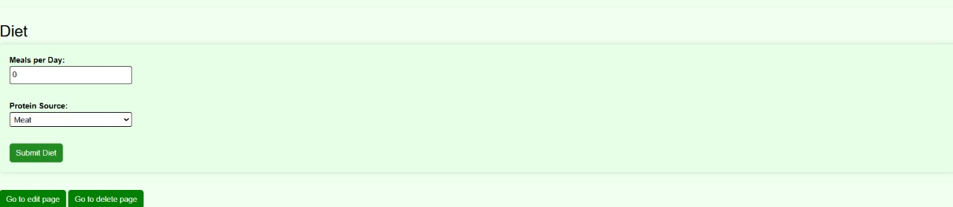

Figure 3.3: Data Entry UI of Green Print system

This page provides users with the ability to edit previously submitted data in three main categories: Energy Usage, Transport, and Diet. Each table lists individual records with relevant details—such as electricity usage, travel distances, meal frequency, and the resulting carbon footprint—alongside timestamps.

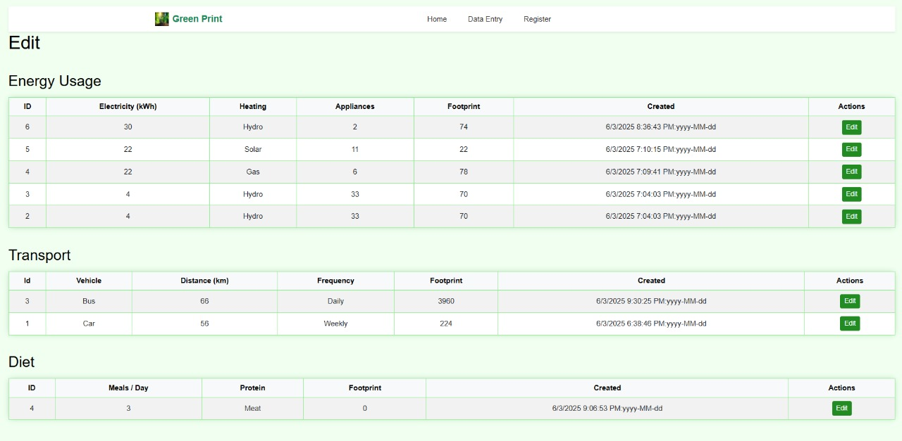

Figure 3.4: Edit page UI of Green Print system

This page displays a summary of user data related to environmental impact in three categories: Energy Usage, Transport, and Diet. Each section lists detailed entries showing consumption habits—like electricity use, heating type, travel distance, and meals per day—along with their calculated carbon footprints and timestamps.

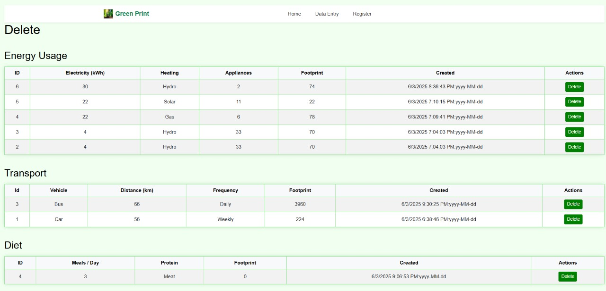

Figure 3.5: Delete UI of Green Print system

